# Kinds of Work in the Course

Technical Writing • Spring 2024 • Traci Gardner

This course includes five kinds of work: Try-Its, Check-In Surveys, Major Projects, Project Wrappers, and Self-Checks. A sixth category, Other Weekly Activities, covers less frequent work. All work is submitted and assessed in Canvas to ensure [FERPA protection](https://docs.google.com/document/d/1uMLa-qk-YWI1iPCnHA-pZ0dVN7B28MRqlC7KG6UYt9w/edit#heading=h.f0cj119358gg). Read more about each kind of work below.

## Try-Its

Try-Its, whether individual or group Try-Its, let you try a writing activity related to the week’s work or the current project without worrying about mistakes. Some activities ask you to write a short technical document. Others present you with scenarios or documents to analyze. All Try-Its are open book: you can use the textbooks, Canvas, and your notes. Usually you have two Try-Its each week.

**Assessment for Try-Its**: As long as you put in the effort for a full response, your work will earn a Complete. Canvas marks most of individual Try-Its Complete automatically. I review them, and if I find you did not give it your full effort or did not complete the activity, I will change the mark to Incomplete. Group Try-Its are marked manually after the grace period ends.

You can revise these activities if I mark them Incomplete, as long at the Grace Period has not ended.

## Check-In Surveys

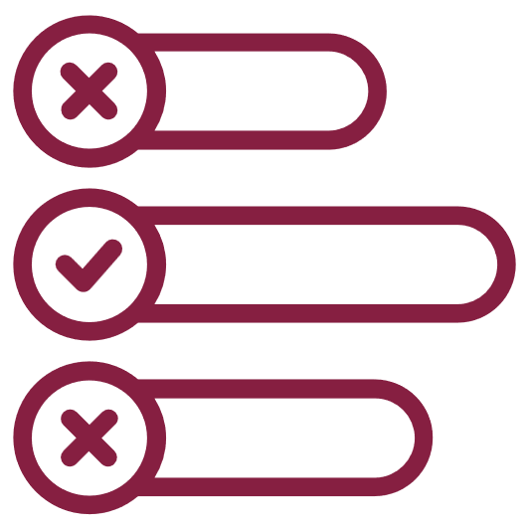Check-In Surveys are short individual activities that ask you how you are doing in the course. I use your responses to customize the course. The surveys are primarily multiple-choice or true-false questions. There are no right or wrong answers. There is a Check-In Survey for each week of classes.

**Assessment for Check-In Surveys:** Canvas marks these activities Complete automatically. In most cases, I will only see the survey statistics and answers in summary. I will never see your name with your answers, unless you type your name in your answer. Your responses will not help or hurt you in the course (as long as you don’t skip the activity).

## Major Projects

Major Projects are the primary assignments in the course. You will compose full technical documents, such as memos, documentation, proposals, and reports. These activities are the most important kind in the course, and they have the strongest impact on your course grade. There are five Full Draft assignments in the course.

**Assessment for Full Drafts:** I compare your Major Project to the rubric attached to each assignment in Canvas. Your project needs a Yes rating for all the criteria listed in the rubric to earn a Complete.

If your work does not receive a Yes for all the criteria, I mark it Incomplete. You can revise and resubmit Incomplete work as long as the Grace Period for Major Projects is still open. This term, the Grace Period ends at 11:59 PM on Friday, April 26, 2024.

## Project Wrappers

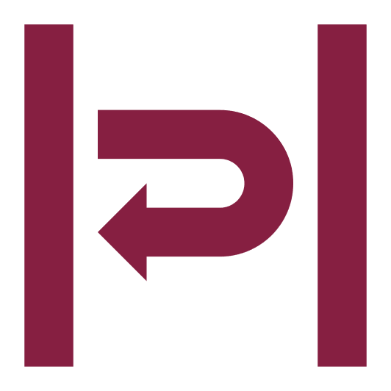Project Wrappers are individual work, comprised of multiple-choice and short answer questions that ask you to reflect on each Major Project as you finish work on it. These assignments wrap around the project—you complete one when you turn your project in, and another when you receive feedback on your project. There are two Project Wrappers for each Major Project, for a total of 10 in the course.

**Assessment for Self-Checks:** Canvas marks these activities Complete automatically. In most cases I review them, and if I find you did not give it your full effort or did not complete the activity, I will change the mark to Incomplete.

You can revise these activities if I mark them Incomplete, as long at the Grace Period has not ended.

## Self-Checks

Self-Checks ask you to compare your working draft to the specifications for a Major Project assignment to assess the status of your project. When you are able to mark all the criteria in the Self-Check as True, you are ready to turn in your Major Project. There are five Self-Checks in the course, one for each of the Major Projects.

**Assessment for Self-Checks:** Canvas automatically marks your Self-Checks Complete. If you do not earn a 1 (Complete) on the survey, revise your project to meet the criteria you marked False. You can complete the checklist as often as you like while the Grace Period for Major Projects is still open.

## Icon Description automatically generatedOther Weekly Activities

Other Weekly Activities are miscellaneous work that does not fit any of the primary categories, such as the Syllabus Review and Student Info Form during the first week of the course. Their frequency varies during the term. These activities fall primarily during the first week of the course.

**Assessment for Other Weekly Activities:** As long as you put in the effort for a full response, your work will earn a Complete. When possible, Canvas marks this work Complete automatically. Otherwise, I will mark the work manually.